**Assignment - 12**

Ques 1: Follow Up the below AWS Architecture Diagram and Create the same in AWS, after created store the cloudwatch logs in the **logs.txt** file.

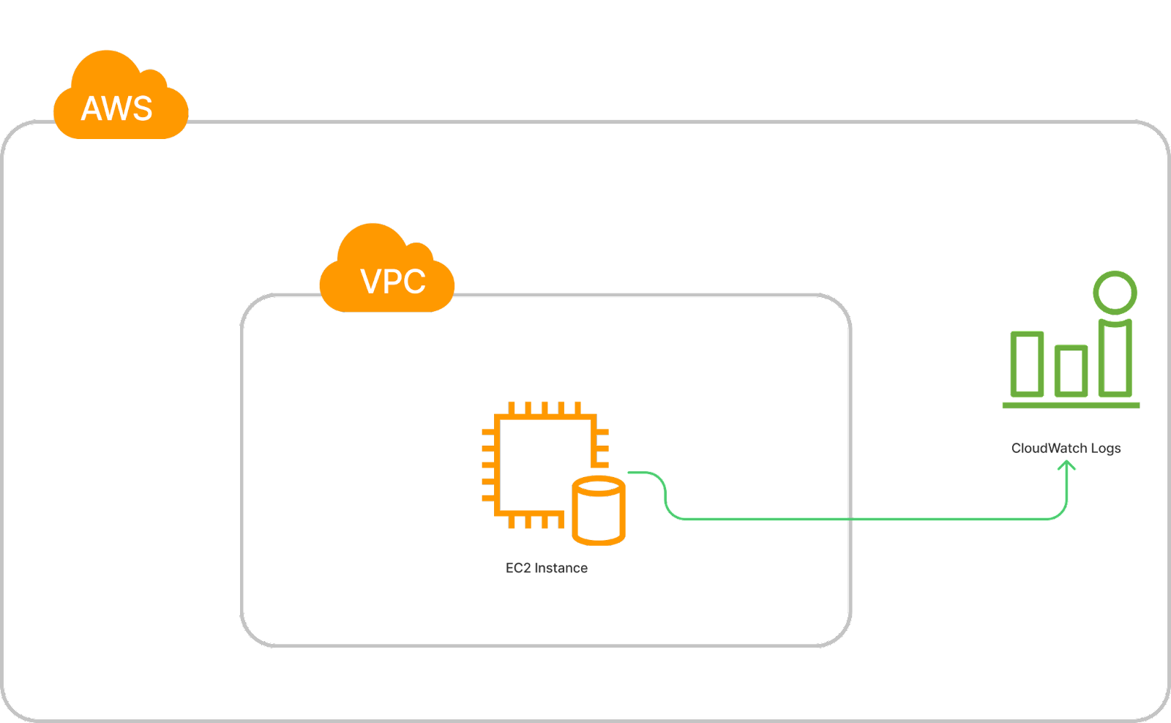

**Ans:**

Created EC2 instance named “EC2-Cloudwatch” on default VPC

And added new IAM role “CloudwatchSeverAgent” to EC2 instance

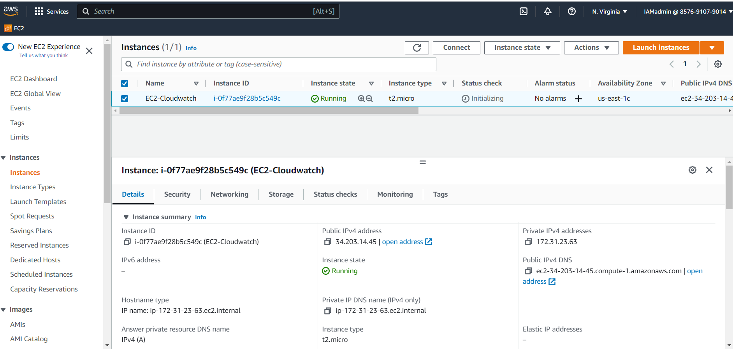

On EC2 machine installed and enabled awslogsd

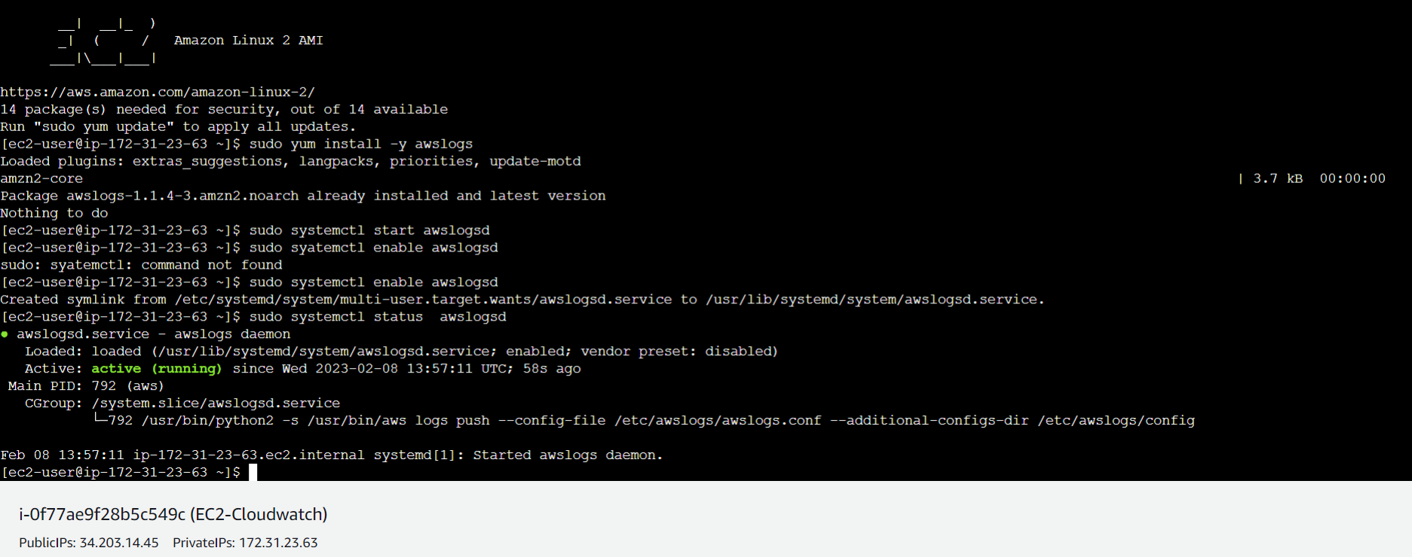

Log group configuration /var/log/messages

Renamed log group name as “aws-logs”

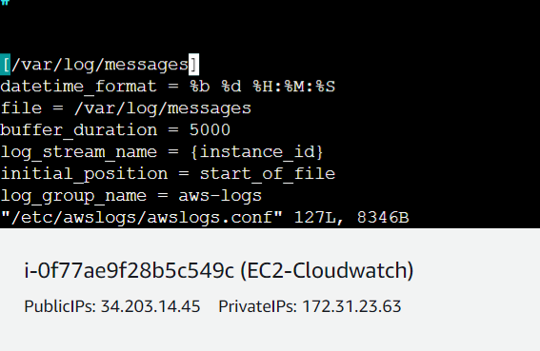

Logs named as “aws-logs” are stored in Cloudwatch

